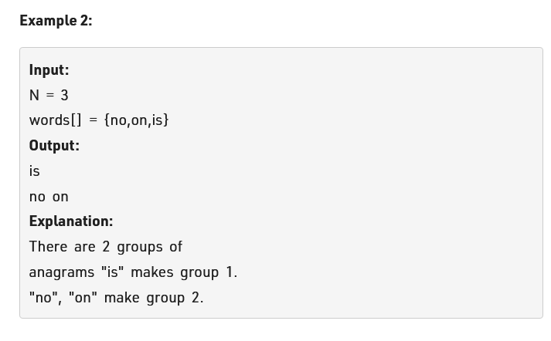

1st approach: n\*mlogm. this is brute force.

Same logic as above brute force.

Now optimal.

We will take a technique that does not involve sorting. We will use a hashmap.

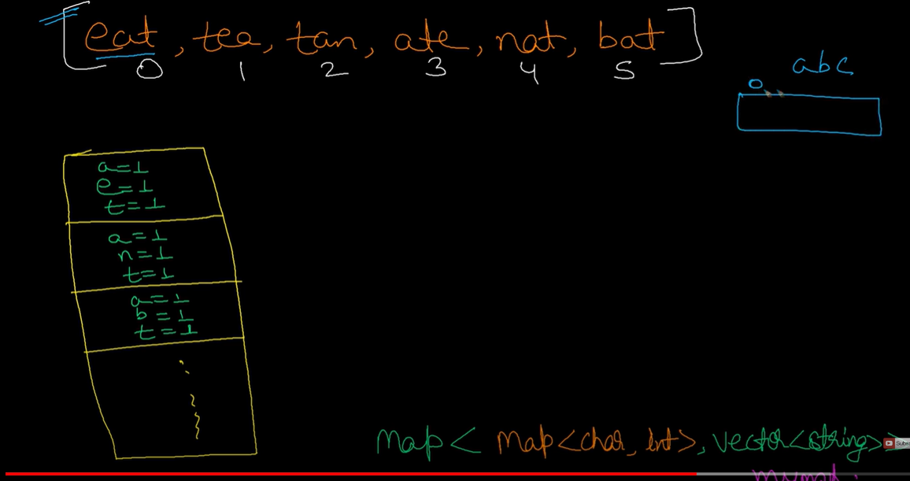

We will take a hashmap and work on it.

See here vector of 26 character is given and a ,b,c has 1 in their index position that start from 0.same for bca and hence we can say they are anagram.

Now how to write it.

Second approach is awesome, we can also solve this problem using trie data structure

Code:

